# MORDERN WEB APPLICATIONS LAB

**PROGRAM NO: 3**

**RESPONSIVE WEBSITE WITH BOOTSTRAP FOR ONLINE BUS TICKET BOOKING**

**AIM**

Develop a responsive website with bootstrap for online bus ticket booking.

**THEORETICAL BACKGROUND**

Responsive web design is about creating web pages that look good on all devices. A responsive web design will automatically adjust for different screen sizes and viewports. Responsive Web Design is about using HTML and CSS to automatically resize, hide, shrink, or enlarge, a website, to make it look good on all devices (desktops, tablets, and phones).

Bootstrap is a widely-used open-source front-end framework for web development and to creating responsive websites, providing a collection of HTML, CSS, and JavaScript components and tools that enable developers to build responsive, mobile-first websites with ease.

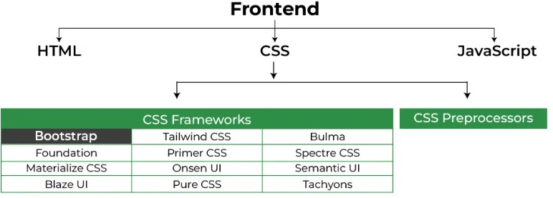

This framework is the most popular because of below mentioned features:

* It is Faster and Easier way for Web-Development.
* It creates Platform-independent web-pages.
* It creates Responsive Web-pages.
* It designs responsive web pages for mobile devices too.
* It is a free and open-source framework available on [www.getbootstrap.com](http://www.getbootstrap.com/)

## Applications of Bootstrap

* Responsive Web Design
* Mobile-First Development
* Consistent Cross-Browser Compatibility
* Customizable Themes and Styling
* Time and Cost Efficiency

## To use Bootstrap on the webpage

There are two ways to include Bootstrap in the website.

## Include Bootstrap through CDN links:

<!– CSS library –>

<link rel=”stylesheet” href=”https://stackpath.bootstrapcdn.com/bootstrap/4.3.1/css/bootstrap.mi n.css” integrity=”sha384- ggOyR0iXCbMQv3Xipma34MD+dH/1fQ784/j6cY/iJTQUOhcWr7x9JvoRxT2MZw1T” crossorigin=”anonymous”>

<!– JavaScript library –>

<script src=”https://cdnjs.cloudflare.com/ajax/libs/popper.js/1.14.7/umd/popper.m in.js” integrity=”sha384- UO2eT0CpHqdSJQ6hJty5KVphtPhzWj9WO1clHTMGa3JDZwrnQq4sF86dIHNDz0W1″ crossorigin=”anonymous”></script>

<!– Latest compiled JavaScript library –>

<script src=”https://stackpath.bootstrapcdn.com/bootstrap/4.3.1/js/bootstrap.min. js” integrity=”sha384- JjSmVgyd0p3pXB1rRibZUAYoIIy6OrQ6VrjIEaFf/nJGzIxFDsf4x0xIM+B07jRM” crossorigin=”anonymous”></script>

# Example:

<!DOCTYPE html>

<html lang="en">

<head>

<meta charset="utf-8">

<meta name="viewport"

content="width=device-width, initial-scale=1">

<!-- Bootstrap CSS library -->

<link rel="stylesheet" href=

"https://stackpath.bootstrapcdn.com/bootstrap/4.3.1/css/bootstrap.min.css" integrity=

"sha384-ggOyR0iXCbMQv3Xipma34MD+dH/1fQ784/j6cY/iJTQUOhcWr7x9JvoRxT2MZw1T" crossorigin="anonymous">

</head>

<body>

<div class="container text-center">

<!-- Text color class used -->

<h1 class="text-success">Computer</h1>

<p>A computer is a machine that can be programmed to carry out sequences of arithmetic or logical operations (computation) automatically</p>

</div>

</body>

</html> Run on IDE **Output:**

## Download Bootstrap from getbootstrap.com and use it:

* + Goto [www.getbootstrap.com](http://www.getbootstrap.com/) and click Getting Started. Click on the Download Bootstrap button.
  + A.zip file would get downloaded. Extract the zip file and go to the distribution folder. It contains two folders named CSS and JS.

<link rel=”stylesheet” type=”text/css” href=”css/bootstrap.min.css”>

<script src=”js/bootstrap.min.js”> </script>

<script src=”https://ajax.googleapis.com/ajax/libs/jquery/2.1.3/jquery.min.j s”></script>

* + Add the file link to the HTML document and then open the web page using web browsers.